**Working Prototype Known Problems Report**

**Tutor+**

**Tutor Squad**

* Sign up page is not a scroll view. So that, the page can’t display name & major field properly while entering the information.

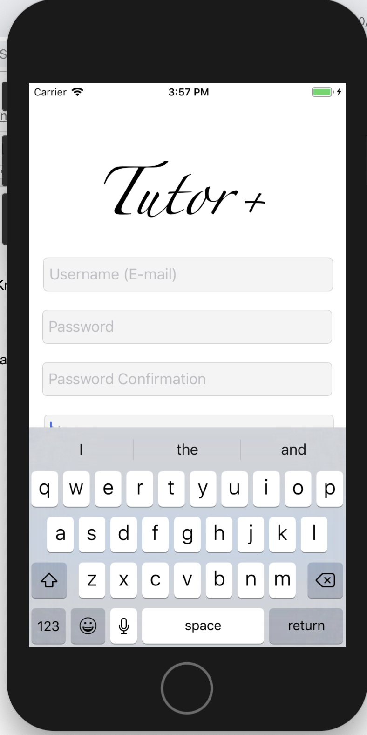

* Error Message displays incorrectly
* Missing “Forgot Password” functionality
* Personal statement in profile edit page doesn’t show placeholder.
* Personal statement in profile edit page cannot detect link from the text.
* There is a potential bug existed, that is when user searing a tutor, the whole app will be crushed.

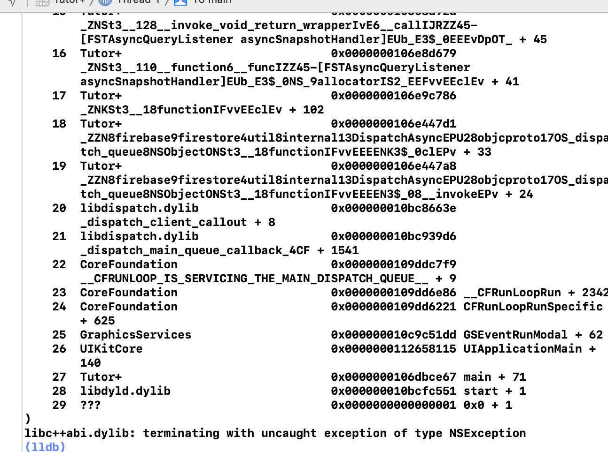

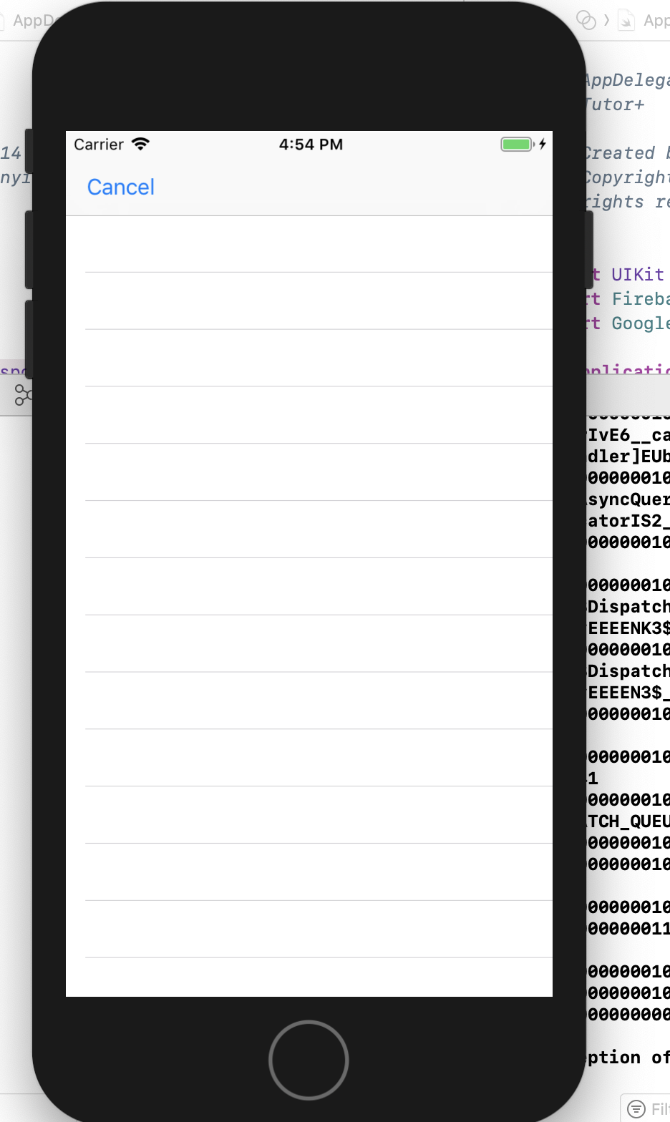

User Stories

**Sprint 1**  
As a user, I want to have an easy and secure login in the system.  
As a user, I want to have a reliable sign up system.  
As a user, I want to have a comprehensive profile system.

**Sprint 2**

As a user, I want to have a great way to see my search result.

As a user, I want able to find the the best tutor and best time for my section.

**Sprint 3**

As a user, I want to use my own friend list to manage my chatting.

As a user, I want to communicate with my tutors/students.

As a user, I want to have some recommendations when I first use this app in search page.

**Sprint 4**

As a user, I want to have a good conversation/chatting environment with my student/tutor.

As a user, I want to have a reliable and good-looking friend list system.

As a user, I want to have a gorgeous initial page.